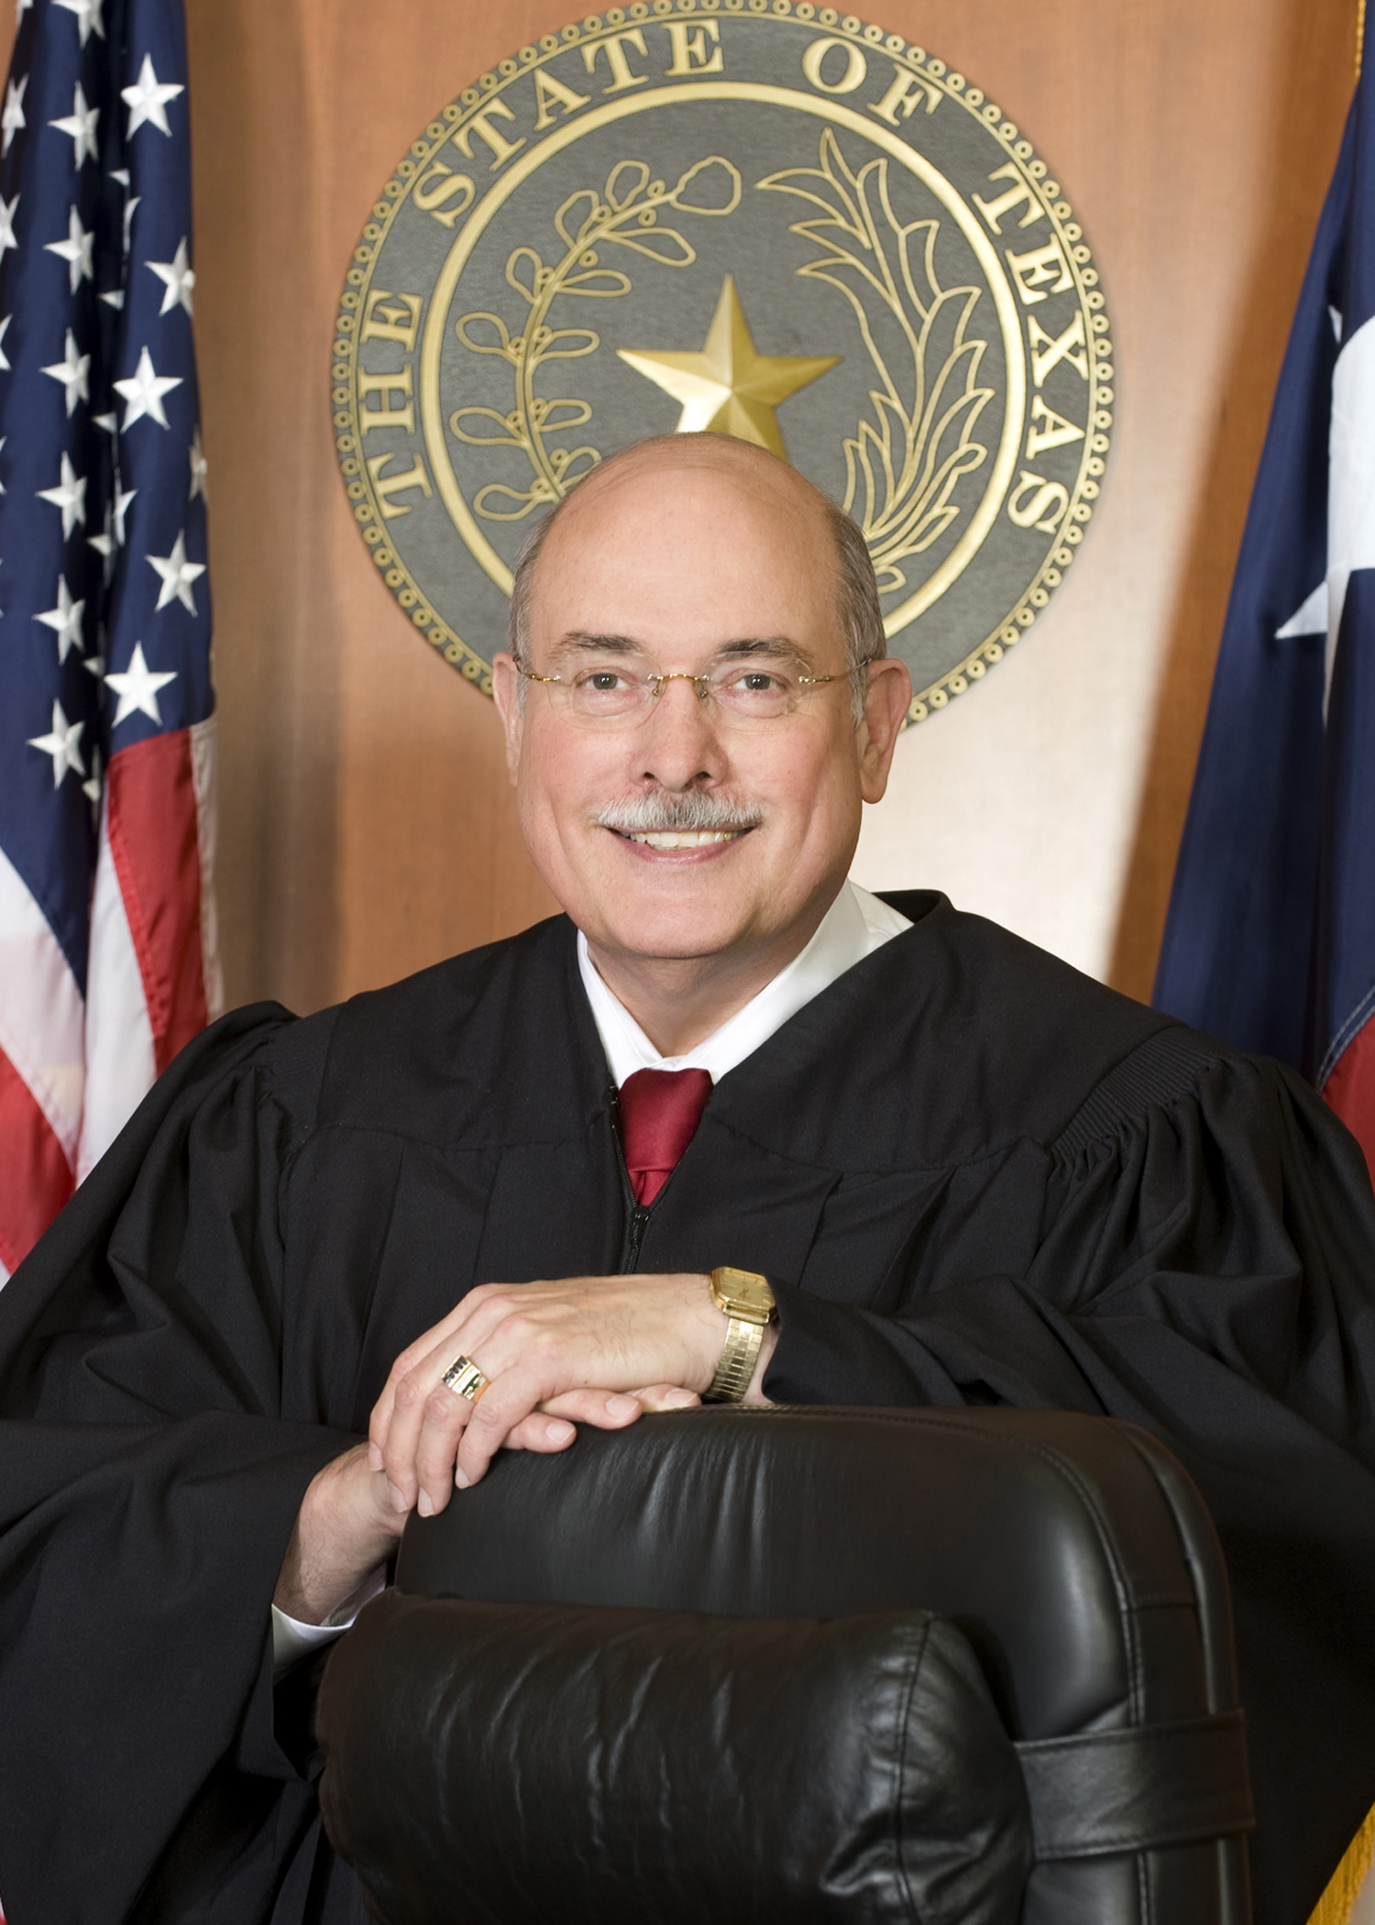

Herb Ritchie, attorney, U.T at Austin, honor graduate (B.A. 1967, with honors; M.A. 1969; J.D. 1974, with honors); Phi Beta Kappa (Honorary Academics Achievement); Phi Delta Phi (Honorary Legal Achievement); Eta Sigma Phi (Honorary Classics Achievement); past teacher/instructor of Classics at U.T.-Austin and Baylor University; Teacher’s Award-Mortgages; third highest grade-Texas Bar Examination; past counsel Texas Real Estate Commission and Southwestern Bell Telephone Co., formerly managing partner, Ritchie & Glass, Law Firm; 32 years experience in both civil and criminal cases and appellate procedure; Board Certified in Criminal Law since 1987 by the Texas Board of Legal Specialization; member: Houston Bar Association, College of the State Bar of Texas. Licensed to practice in all Texas Courts, Southern, Western and Eastern Districts of Texas, Fifth Circuit Court of Appeals, and U.S. Supreme Court. Elected Judge 337th Criminal District Court, November 2008.
“I believe in and will work for a system of justice whereby every person, regardless of status, receives fair and equal treatment under the Law.”

