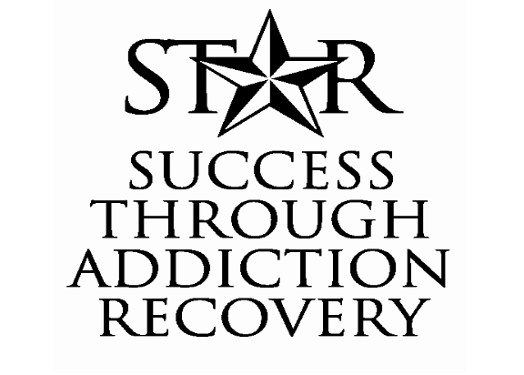

STELLAR SUCCESS
September 2006 • Harris County Drug Court Program • Volume 1 • Issue 4

Shining STAR—Kelly V.

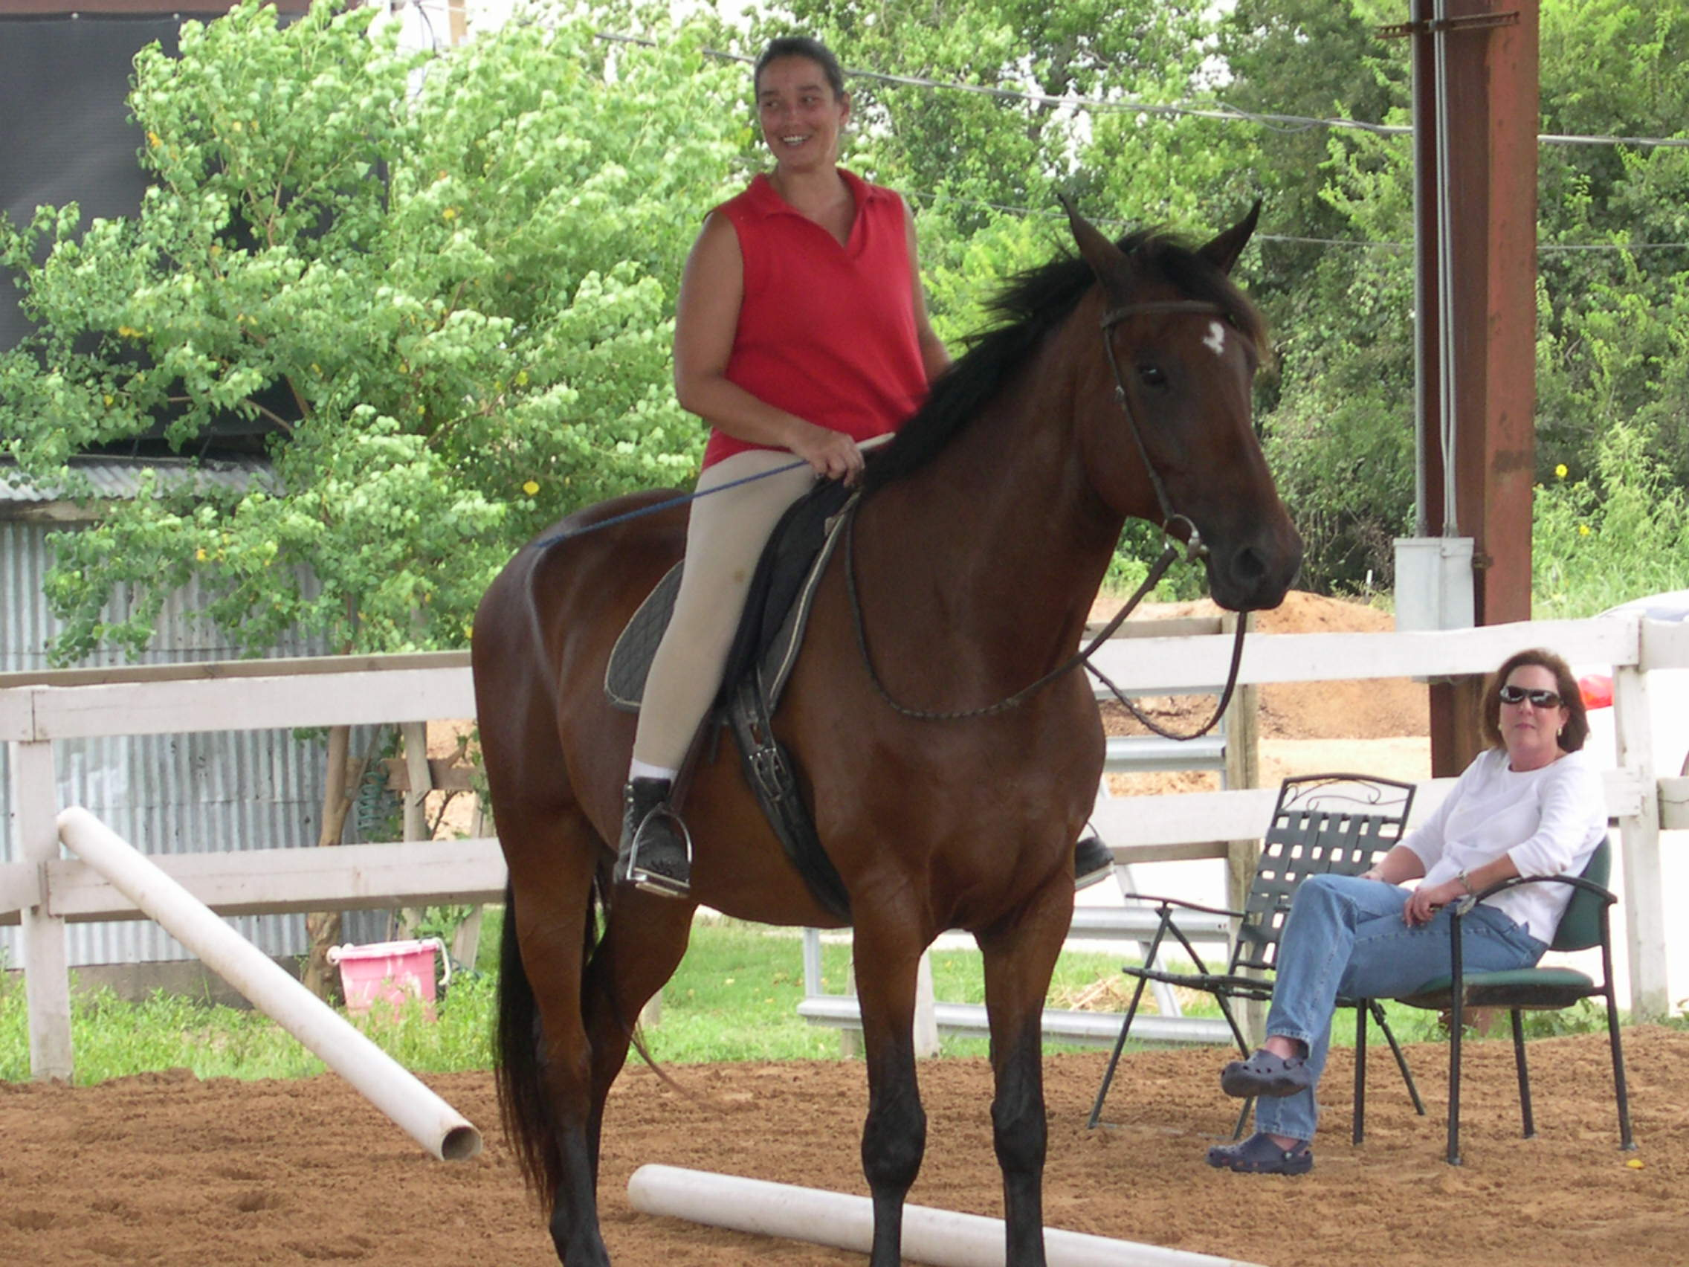
Kelly V. is proud of her recovery and is not afraid to show it. Literally. Kelly looks forward to showing her newly purchased dream horse, an animal made special because he is a symbol of her accomplishments in recovery.

She lovingly named her horse “Dream S.T.A.R.” after the program that guided her on the road to recovery. During her addiction, Kelly never had the means to purchase an animal like Dream S.T.A.R., but regaining her sobriety also helped Kelly gain the responsibility to help achieve her dreams of rejuvenating her stables at Foxfire Farms.

Kelly graduated from the STAR program in March of 2006 and feels that she found a good balance in her life. She attends more meetings than she is required to, but she enjoys the routine and hard work of both the STAR program and her work at the stables. Her dedication to her farm pays off as new students and new horses continue to arrive.

Besides the farm, Kelly spends much of her energy with her family, including her very supportive husband who attended countless meetings and other sober events. Kelly also has four children: her daughter Austin, her twin boys Cash and Clay, and her youngest son Russell.

At her graduation Kelly offered STAR clients’ children the opportunity to attend her summer riding camps at Foxfire Farms free of charge. She remembered how hard it was during the early stage of her recovery to provide anything to her children and wanted STAR parents to “share a moment in time” with their children.

While the plan faced transportation issues this summer, the STAR program will help Kelly arrange an All-STAR camp for STAR client’s children in the future. Kelly’s thoughtfulness and generosity embodies the positive life change that addiction recovery has on a person, and STAR wishes her and Dream S.T.A.R. luck on their future shows.

.

Stellar Support: STAR Case Mangers

As STAR clients know, the case manager is an important role in the drug court team. This person works as the link between the
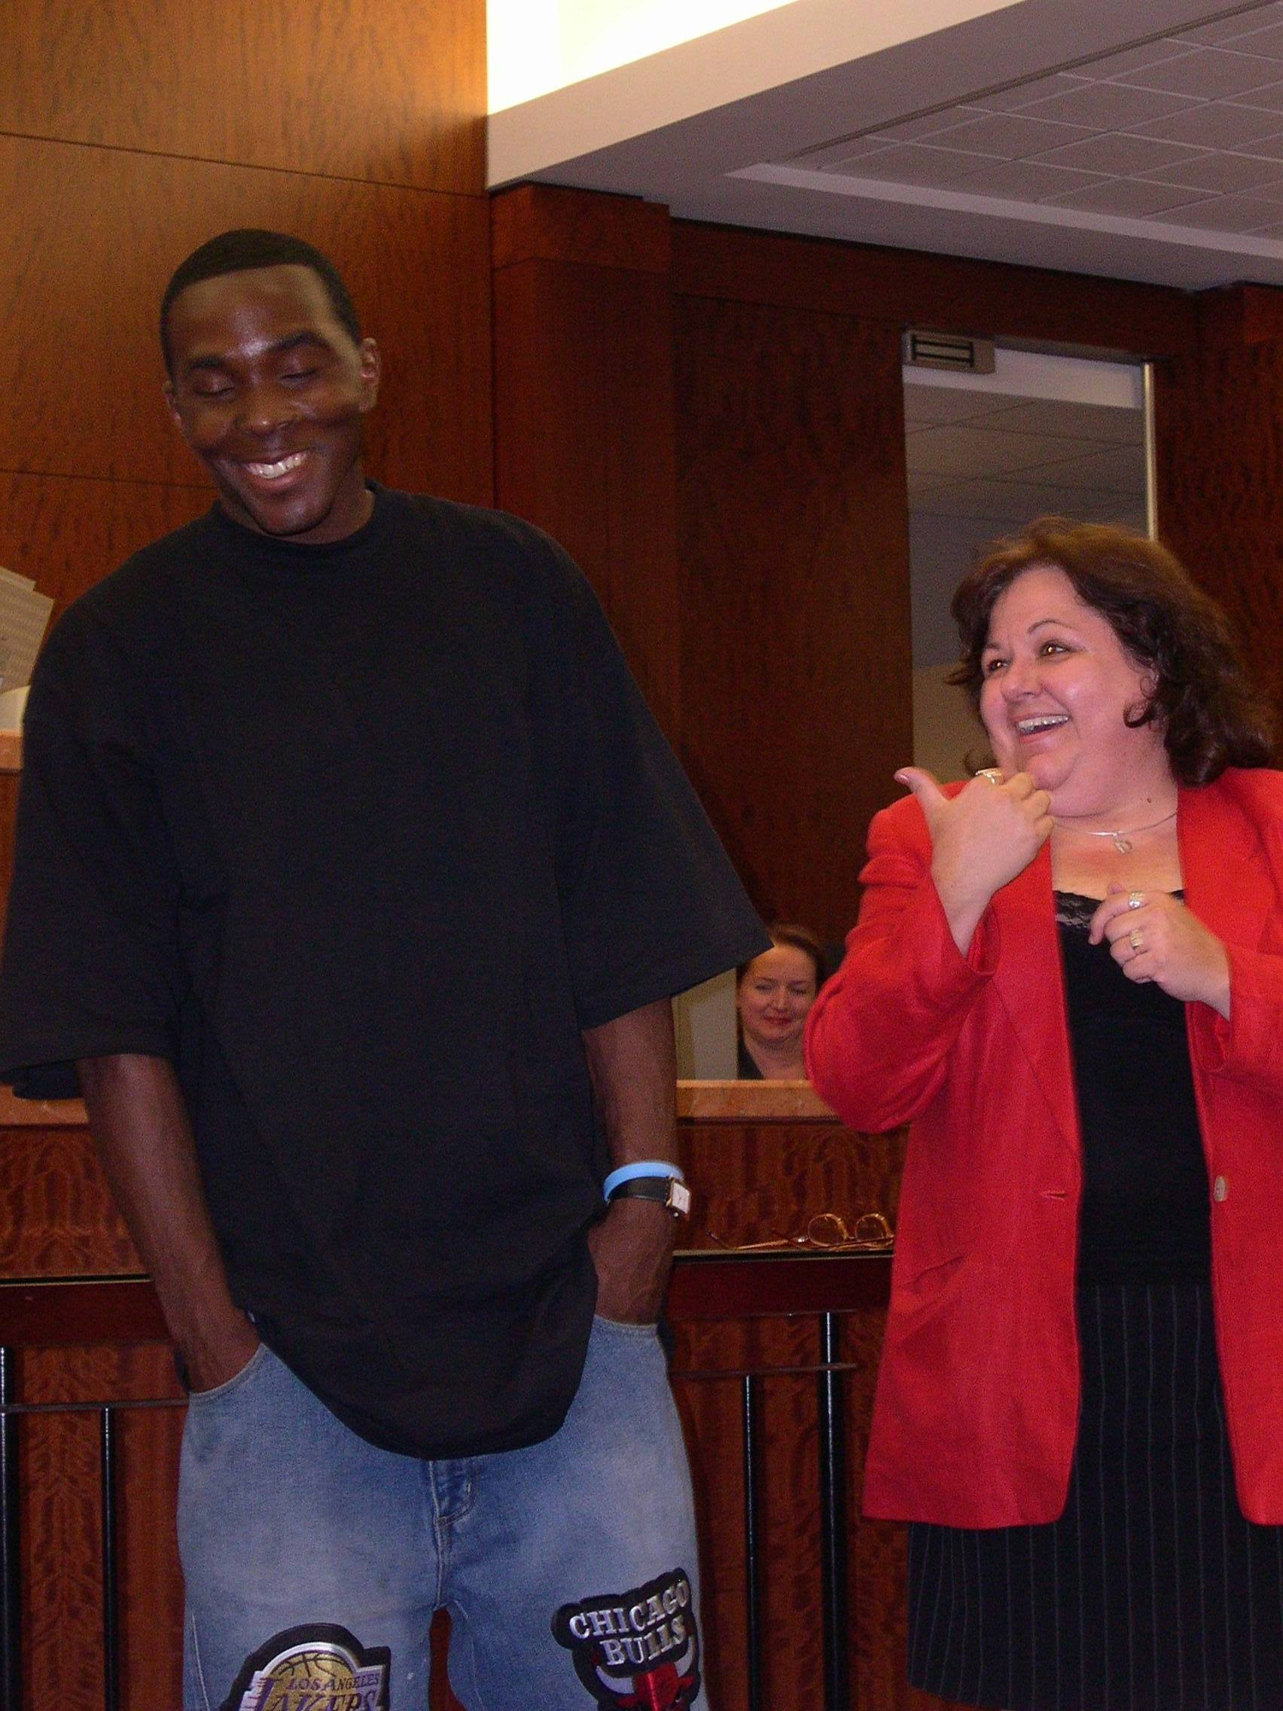
judge and the client, often acting as a probation officer, a counselor, and a friend to many of the STAR clients. Without case managers’ accurate and timely information, the drug court would not be the personal and positive environment that it strives to be.
STAR Case Manager Assistant Supervisor Delia Canamar describes the role of the drug court case manager as “the eyes and ears of the court” by providing information, documentation, and making crucial relationships with the clients.
The case managers struggle with the difficult, comprehensive task of playing many roles to the client and the court. They handle assessments, act as CLOs, follow through with release contracts, arrange treatment for the client, and bond with the clients and their families.
Currently, STAR employs five case managers: Beverly Robinson works with Judge Wilkinson’s Monday docket, Yakia Hall works with Judge Cosper’s Wednesday docket, Felicia Lucas works with Judge Thomas’s Thursday docket, Ana Velasquez handles the overload client cases, and our new team member Ellen Minton will handle the STAR graduates.
Former case managers Delia Canamar and Raymie Hairell-Sweat returned to our program this summer as assistant supervisor and supervisor, respectively, with the experience and enthusiasm to inspire our case managers and our entire drug court team.
This very diverse group has varied backgrounds, but all of the STAR case managers have long histories with the Community Supervision and Corrections Department and/or the criminal justice field.
They all know the importance of maintaining the client relationship and the impact they have on the program. Canamar says the case managers play an incredible role because “what we do and say can make a difference in [a client’s] life.”
The best aspect of the case manager’s job is experiencing clients’ success, whether it be family reunification, graduation, or even just a continual positive attitude. The STAR program thanks this essential team of drug court professionals and the impact they make on our clients’ lives everyday.
The case manager
is the link between
the client and the judge.

Delia Canamar praises Royce J., her former client who graduated from the STAR program this summer.
STAR Court Announcements

Fall Graduations
This fall we will graduate several deserving members of our STAR program. Please join us on Monday, September 5th and Thursday, September 7th in the STAR Courtroom at
3 pm to celebrate the achievements of our clients’ stellar success.

STAR Client Banquet
An awards banquet for STAR clients will be November 17, 2006 at the Holiday Inn Southwest at 7pm. STAR Alumni Kathryn G. arranged this event in celebration of all of STAR’s successes. STAR will present awards to several deserving members and honor all clients with a special night.
Recovery Month
September is National Recovery Month, an effort to build a stronger, healthier community by supporting recovery and awareness. Remember to honor both people in recovery and treatment providers. Visit http://www.recoverymonth.gov/ to learn more.

STAR Court Announcements

Guests STARS
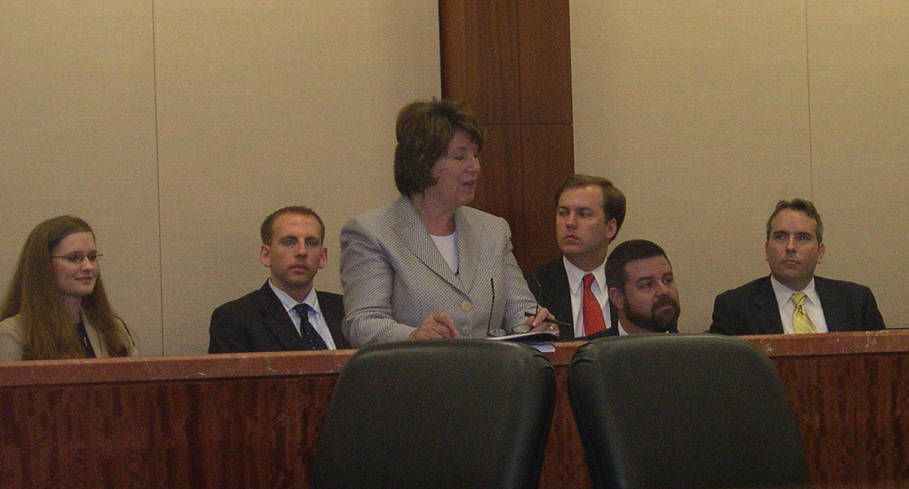
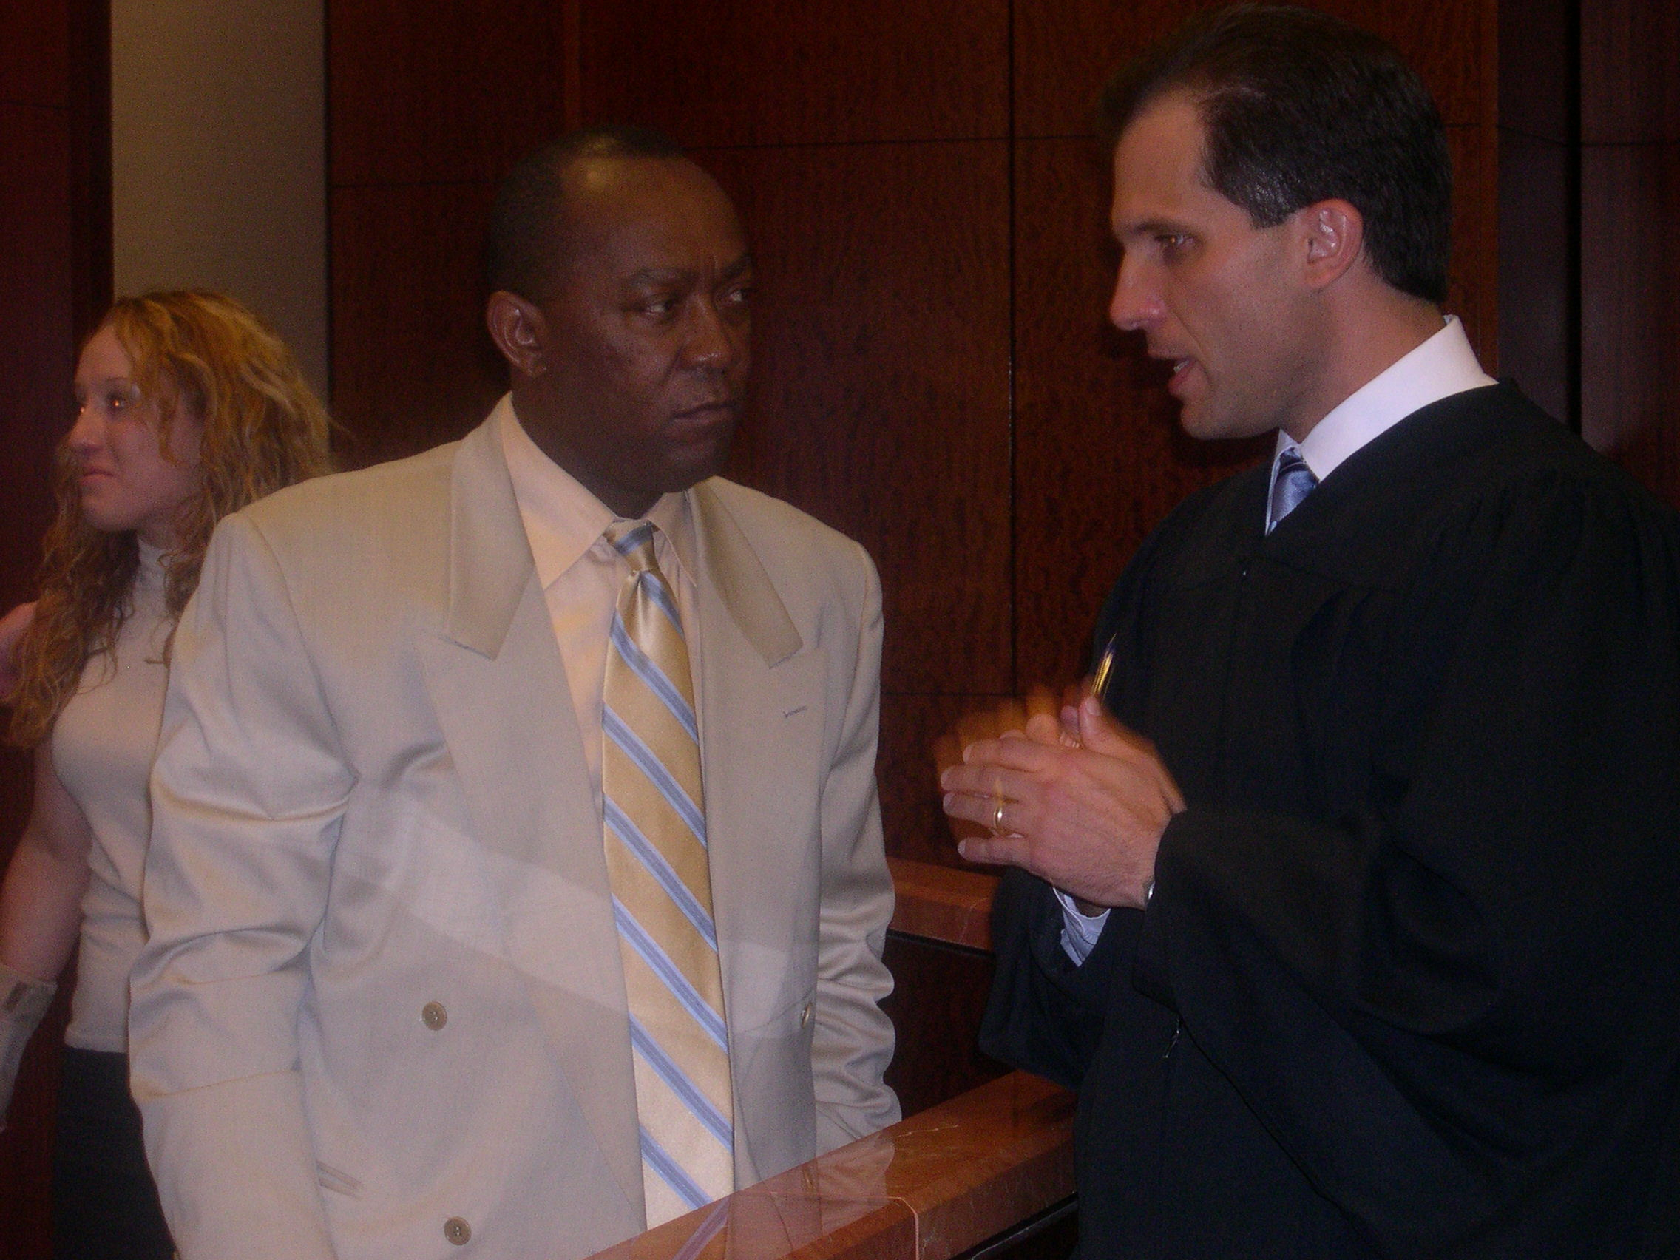
Last May STAR had the honor of hosting Dr. Bertha Madras, Deputy Director Demand Reduction, Office of National Drug Control Policy. Other officials also attended STAR, including Nathan Cook, Deputy Regional Director, Office of Senator John Cornyn; Jason Fuller, Regional Director, Office of Senator Kay Bailey Hutchinson; Stephen Katsurinis, Chief of Staff, Office of National Drug Control Policy; Rayel McKennett, Program Support Specialist, Drug Policy Office; and Nicholas Swyka, District Director, Office of Representative John Culberson. Many guests observed drug court proceedings for the first time. This visit gave STAR the opportunity to present the successes and challenges of the drug court model. Dr. Madras praised the STAR clients, encouraged them to continue their recovery, and reminded them that their continued success improves the future of drug courts.

Acknowledgements—A Message of Thanks

I want to thank personally all of our STAR Partners and their continuing efforts that make our program possible.
A special thanks to the following:
Peter Brown for donating the school supplies. Several STAR parents were able to gather much needed supplies for their children this school year;
Rep. Sylvester Turner for attending the June graduation and for your continued support;
Judge Brock Thomas discusses the STAR drug court with
Rep. Sylvester Turner.
And, finally, Katherine Cabaniss, STAR Assistant District Attorney, who recently left our program to become the Executive Director of Crime Stoppers’s Houston Branch. STAR wishes our friend good luck on the next stage of her career.

Thank you again.

Mary Covington
STAR Program Manager

STAR Drug Court Program
Houston, TX 77002
1201 Franklin, 14th Floor

For more information, please contact
Mary Covington at 713-755-4610

