proto

STELLAR SUCCESS
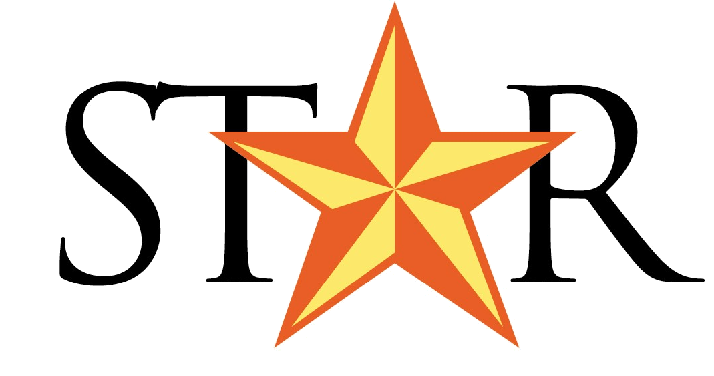
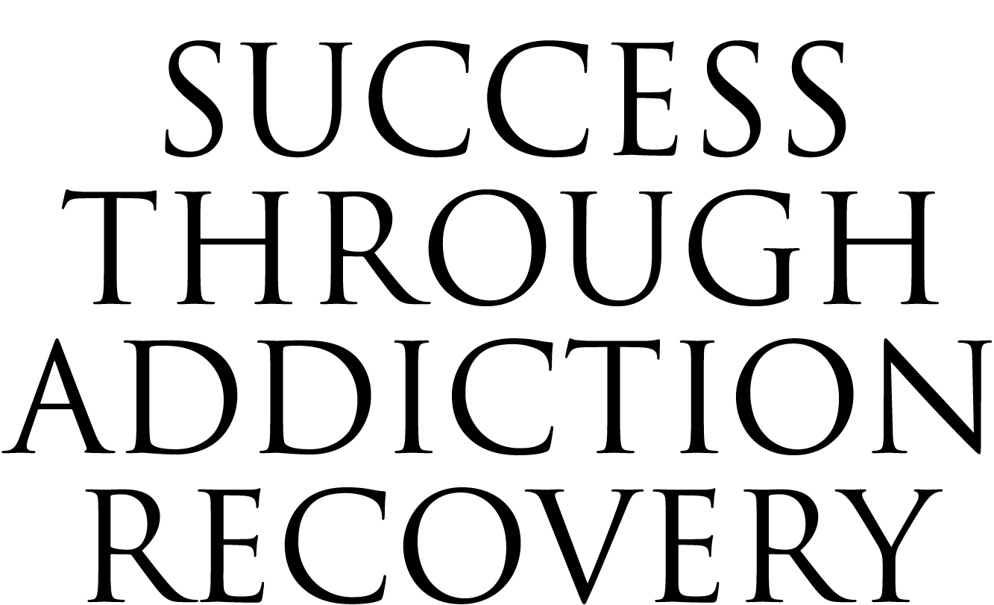

March 2007 • Harris County Drug Program • Volume 3 • Issue 1

Being Dazzled
After more than nine years of sobriety, B’Dazzled resale boutique owner Debbie Damon is giving back – in her own beautiful way.

Today, Debbie Damon deals in glamour, but in 1995, she was dealing with something very different. “The first time I met Mary [Covington] and Judge Cosper was in 1995, when I had my first felony case for possession and they put me in Gulf Pines, which was a 30-day rehab facility,” said Damon, the owner of the River Oaks resale boutique, B’dazzled. “I stayed sober for about a year, and then I went back out and used again . . . and I got busted again. Judge Cosper knew me as a paralegal, and she knew I needed some help. So, she let me sit in county jail for 12 months and then she sent me to SAFPF for nine months and two weeks and New Directions for 90 days, and I’ve been clean and sober ever since.”
“Ever since” began on June 27, 1997, and Damon has had no trouble keeping herself occupied in that time. “I was asked numerous times to sponsor, and I thought, no, I don’t want to sponsor,” Damon said. “I would rather go back . . . and teach the girls how they can look at themselves in the mirror again, buff and fluff them. That’s how I got into Mary Kay.”
“Many of us have a hard time [liking what we see in the mirror while] going through recovery. We just see our shame instead of the little flower that needs to blossom,” said Damon.
Damon is a Mary Kay consultant, and her position has allowed her to purchase the products at half-off retail price, so she can use them in her workshops with women in recovery. It has also allowed her to be in the top 20 in sales in her regional area for the past five years, which

Debbie Damon Stands next to just a few of the
designer gowns B’Dazzled offers.

explains the bright red Mary Kay car sitting in the B’Dazzled parking lot.
It was through her workshops that Damon had a brush with her past a few years ago. One of the girls in Damon’s class told STAR Drug Court Manager Mary Covington about Damon’s work. “I still needed to make amends to both [Judge Cosper and Mary], because I thought some really bad things about them,” said Damon.
Damon told the girl to give Mary her card, and to have Mary call her. “One thing led to another, and we decided to spring a little surprise on Judge Cosper. I approached the STAR Drug Court with my story. And I’m sitting in the front, and I’m looking at Judge Cosper, and I was kinda waving at her, and she kept looking at me, and [then] she stopped the courtroom. And she said, ‘Ms. Damon I thought you were living in Florida!’ She even remembered. And to make a long story short it’s been a beautiful relationship with them ever since.”
Continued on Page 2 – B’dazzled

B’Dazzled – Continued from Page 1

Dozens of women have benefited from that surprise visit to make reparations. Damon has worked with STAR court to provide women with gifts for graduation, Mother’s Day, Valentine’s Day, and Christmas. She also donates many shaving kits for the men of STAR Court, and in December of 2005, she hosted a makeover workshop for STAR alumni.
A year ago Damon had the opportunity to purchase B’Dazzled. Because of her felony, she was turned down by five banks before finding someone willing to back her. Damon had already established a lot of connections for the store, and she continues to use B’Dazzled as another way to give back.
“A lot of our consigners who bring clothes here, instead of taking the clothes to other thrift stores if we can’t use them here, will leave the clothes here, and we send the donation to Santa Maria, to the women,” said Damon. “And as part of our Web site for B’dazzled, there’s a little icon called ‘Project Giving Back,’ and they click on it, and they know exactly what the girls need. The drop off location is there.”
“So primarily what we’ve done is we’ve come full circle,” Damon said. “We’ve made B’dazzled a wonderful resale store, but it’s also

giving back, it’s teaching, it’s helping me stay clean and sober because the girls remind me [of] where I used to be. I love being here.”
“I wanted a real solid reason to stay sober and I know that yes, I still think of my drug of choice. It just happens. But what keeps me sober is going and teaching the classes, and talking to the girls,” said Damon. “I just couldn’t face them if I ever went out and used again . . . It’s going to the STAR drug courts, it’s going to the Santa Maria graduation, it’s going to Santa Maria every Monday and teaching the classes that helps me stay sober and clean. Most people just think they go to drug court and treatment for their husbands. And I’m staying clean and sober for more than just one person – for a lot of reasons, a lot of women.”

B’dazzling Boutiquish Bungalow
1308 W. Gray (between Waugh Drive and Montrose – North side of the street next door to Import Warehouse)

713-387-2525

http://www.bdazzledresaleboutique.com

A Different Path

When you place a phone call to someone at Pathway to Recovery, you will often hear birds singing in the background. That trilling is the first sign that Pathway is not your standard treatment provider.
Pathway’s building looks more like a rambling summer home than a treatment facility, and the grounds are dotted by sprawling oak trees. The exterior, however, is just the beginning of what makes Pathway unique.
“Our treatment philosophy is to provide the best possible care in the least restrictive environment, and to focus on the families,
because that’s where the treatment has its ultimate success – in treating the family, not just the


A front view of Pathway to Recovery’s grounds.

individual,” said Pathway Vice President and Chief Financial Officer Dave Middleton.

Although Pathway focuses on families in its treatment approach, its clients are all male. “Once you mix male and female, the tendency is to focus on relationships, and that overrides and overpowers the focus on treatment . . . so we’ve made the facility all-male, just to eliminate any outside focus the clients have, and to allow them to focus on therapy,” Middleton said.
Pathway prides itself on offering its clients a wide range of services that extend beyond basic treatment. “We offer a lot of services that other inpatient service providers just do not offer,” said Middleton. “We assist clients with getting medication for any co-occurring psychiatric disorders. We also assist clients in obtaining a GED, or going to classes to obtain a GED . . . Our staff is [also] very diverse in terms of treatment approach and modality. We like to think that we have the most diverse treatment of any facility in the area, which includes occupational therapy, and psychodrama.”
According to Middleton, STAR Drug Court and Pathway have worked together since the inception of the court. “At times, if a client needs medication [we will] purchase a client’s medication at no cost and not charge it back to drug court. We see [STAR] as one of the most phenomenally successful programs out there. It’s rewarding to see clients [who] come through drug court succeed at a rate where our other contracts just don’t . . . We wish [STAR] would expand and offer the program to more people.”
The partnership between Pathway and STAR is one appreciated by clients as well. One STAR graduate said Pathway provided him with the tools he needed to get clean: “One thing that I can always revert back to is ‘think it or play it through.’ That has helped me so many times to avoid doing anything that would cause me to relapse.”

STAR Announcements

National Drug Court Awareness Month
May is National Drug Court Awareness Month and the National Association of Drug Court
Professionals has released their 2007 Drug Court Month Field Kit.

http://www.nadcp.org/

Thank You, Mr. President
An article on the Harris County STAR Program titled “Tough Love in Texas” was featured on page 26 of the National Drug Control Strategy released by the White House.

http://www.whitehousedrugpolicy.gov/publications/policy/ndcs07/

Summer Graduation – Save the Date
In celebration of Commencement Week during National Drug Court Awareness Month, STAR will hold a combined graduation for all three STAR dockets on Wednesday, May 30th. The commencement ceremonies will take place at 3:00 p.m. in the Ceremonial Courtroom, 1201 Franklin, 20th floor. Please make plans now to join us in honoring our summer graduates.

Moving On . . .
Long-time STAR defense attorney Ron Nicholas has resigned from STAR Court after accepting a position as a Criminal Law Hearing Officer for Harris County. Ron was invaluable to STAR Court and is already sorely missed.

Congratulations Ron – just remember that we still know which directory you’re in.

. . . And Moving In
STAR Court is happy to welcome the two newest members of its team, defense attorneys Deborah Keyser and Michelle Beck. Both bring a history of outstanding service and a passion for the mission of STAR Court. Welcome aboard, ladies.

A Word of Thanks

By the time you read this, STAR Drug court will have honored its 100th graduate, an achievement only made possible by the support of our phenomenal partners, a few of whom I would like to personally thank:
Thank you to STAR alumni Kathryn G. and Ryan C. for all of their hard work in organizing and hosting the First Annual STAR Client Awards Banquet in November, and the alumni Christmas party in December. Both were a rousing success.

STAR Drug Court Program
Houston, TX 77002
1201 Franklin, 14th Floor

For more information, please contact
Mary Covington 713-755-4610

Thank you to Houston City Councilman Peter Brown for his donations of stockings and
toys to the children of STAR clients this Christmas season.
Thank you, likewise to City Councilman Ronald Green for his donation of several bikes that were raffled off to STAR clients.
I know that somewhere, Santa is beaming.
Thank you again for your continued support.

Mary Covington,
STAR Program Manager

