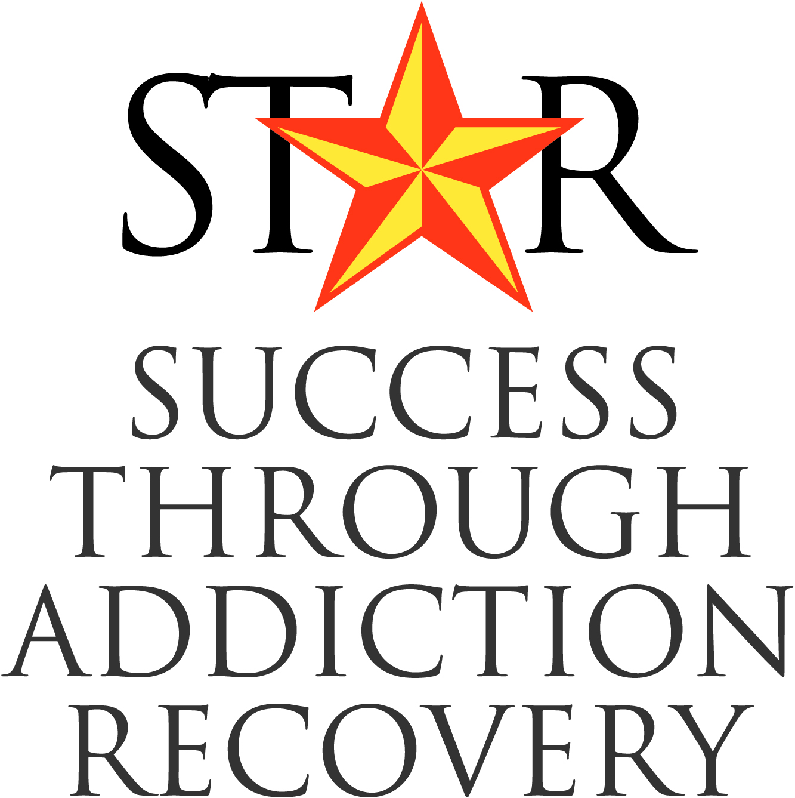

STAR DRUG COURT

ALUMNI ASSOCIATION

**Welcome Packet**

(Rev. 5/2020)



***Welcome from the President***

First of all I would like to say to all the graduates **congratulations**, and welcome to the ALUMNI ASSOCIATION!

STAR COURT taught me how to be a functional member of society. The ALUMNI ASSOCIATION taught me how to have fun in recovery.

I get to come to the alumni meetings every month and I get to see my family. I say family because I know that if needed, any one of the members would have my back in a second. Whether it’s someone just to talk with or someone to call me on my behavior or attitude. One thing that is for certain, wherever we go, **we always have fun**, and make the best of any situation.

Just know you are not at this alone; we have all been where you have been. We also went through a lot of the same growing pains in our new life. Always remember that we are all family and **we have your back**.

So welcome to the STAR COURT ALUMNI ASSOCIATION.

Christie

Christie Peters

*Alumni President*

***“Though no one can go back and make a brand new start,***

***anyone can start from now and make a brand new ending”***

** *Welcome from the Advisor***

*Welcome New Graduates:*

*Congratulations on completing the initial phase of your STAR Drug Court Program and continued best wishes as you embark on the next part of your journey toward completing your legal requirements of probation.*

*To do that, your dedication and unwavering focus on your personal recovery program is critical. As you know, this can be a time when people tend to stray from their recovery regimen of routine 12 step meeting attendance, consistent contact with their sponsor and living by the 12 steps.*

*We have full faith in you and that you will continue to live your recovery just as you have been, and that when any issue that life throws at you, that you will remember the amazing amount of resources that you can immediately call upon for support. One of those is the STAR Drug Court Alumni Association.*

*Where else can you find a group of energetic, committed, like-minded people who have truly walked in your shoes and very possibly already experienced what it was like to transition from the court-focused mentality to having more freedom and independence where you must self monitor? It’s a place to find new sober friends, possibly a new sponsor, roommate and a heck of a lot of fun!*

*Please know that your Drug Court Family is still here for you every step of the way so never hesitate to call upon us! No problem is so great that to use mind altering chemicals or resort to old behaviors is the answer. Make the healthy choice to reach out because we are here.*

*Blessings and welcome to the SDCAA!*

*Keith Liles*

*Keith H. Liles, BA, LCDC, ADC III, ICADC, NCAC II*

*Program Manager & Clinical Director*

*Harris County STAR Drug Court Program*



***Board of Directors***

**2020 Contact Information**

|  |  |  |  |
| --- | --- | --- | --- |
| **OFFICE** | ALUMNI | PHONE # | EMAIL |
| **President** | Christie Peters | 346/401-4616 | Sissleep84@gmail.com |
| **President-Elect** | Cassandra Latulippe | 281/571-5888 | cassandralatulippn@gmail.cpm |
| **Vice Pres/**  **Fundraising** | Nano Johnson | 832/857-7307 | Nanojohnson57@gmail.com |
| **Secretary/Treasurer** | Jeffrey Moten | 832/537-8071 | Jeffdadeandsd1@gmail.com |
| **Sergeant**  **at Arms** | Sylvanus Turner | 832/949-8200 | Sylvanusturner1@gmail.com |
| **12 Step Meeting Oversight** | Glenn Allen | 281/662-1044 | Allenglenn065@gmail.com |
| **Alumni Advisor** | Keith Liles | 832/927-4323 | Keith.liles@csc.hctx.net |

June, 2017 Class President: Nancy Hill

September, 2017 Class President:Jessica Yeager

December, 2017 Class President**:** Will Whittington

March, 2018 Class President: Wesley Walker

June, 2018 Class President: Pamela Korey

September, 2018 Class President: Erik Richards

December, 2018 Class President: Amanda Cooper  
March, 2019 Class President: Latrice Kelly

June, 2019 Class President: Melvin Pressley

September, 2019 Class President: Ruth Rodriguez

December, 2019 Class President: Cassandra Latullipe

March, 2020 Class President – Christi Peters

**Meeting Information**

**Time: Graduates:** Second & Fourth Wednesday of every month; 7-8pm

**Phase III Clients:** Second Wednesday of every month; 7-8pm

**Location:** The Council on Recovery-Houston, 303 Jackson Hill, Houston, Texas 77007 – Check marquee in lobby for room location

**Attendance:** Mandatory

** *Calendar of Events***

***2020 STAR Drug Court Graduations***

August 31

November 30

***Quarterly Reviews***

July 20-23

October 19-22

***Alumni Picnic***

TBD

***13th Annual Houston Candlelight Vigil***

October, 2020

Houston City Hall

***10th Annual Houston Run for Recovery***

2021

** *ALUMNI & PHASE III CLIENT CONTACT INFORMATION***

Revised 5/2020

|  |  |  |  |
| --- | --- | --- | --- |
| **NAME** | **PHONE #** | **EMAIL** | **BDAY** |
| **Glenn Allen** | 281/662-1044 | Allenglenn065@gmail.com |  |
| **Reginald Allison** | 346/757-7770 | Reggieallison27@gmail.com | 4/27/81 |
| **Daniel Boone** | 832/879-4050 | Boonedan20@gmail.com |  |
| **Lauren Brock** | 832/342-8085 | Laurenbrock28@gmail.com |  |
| **Christopher Brown** | 346/284-6760 | Cherho6385@gmail.com |  |
| **Tory Campbell** | 346/373-7571 | Torycampbell2019@gmail.com |  |
| **Delores Cervantes** | 346/288-4619 | Delorescervantes9@gmail.com |  |
| **George Costello** |  |  |  |
| **Carl Davis** | 832/896-7435 | carledwindavis@gmail.com |  |
| **Ketan Desai** | 713/384-5320 | Ketan1019@yahoo.com |  |
| **Victoria Donnell** | 346/309-6533 | None |  |
| **Haley Douglas** | 832/233-2592 | None |  |
| **Ryan Epps** | 281/883-4673 | rvepps@icloud.com | 04/22/95 |
| **Crystal Ferguson** | 979/308-6611 | Crystalferguson2019@gmail.com |  |
| **April Finger** | 346/217-7394 | Apriljeane3@gmail.com |  |
| **Paul Garcia** | 346/263-1390 | Guddha1984@gmail.com |  |
| **Nicole Gilbert** | 713/972-2547 | niccinicolergilbert@yahoo.com |  |
| **Johsua Goodman** | 346/350-1776 | Jgoodman93@gmail.com |  |
| **Kenneth Hagardorn** |  |  |  |
| **Sharika Harris** | 832/214-8216 | Sharika.harris@yahoo.com | 08/12/77 |
| **Victoria Hawthorne** | 832/989-1665 | Victoriahouston059@gmail.com |  |
| **Nano Johnson** | 832/857-7307 | Nanojohnson57@gmail.com |  |
| **Cassandra Latulippe** | 281/571-5888 | cassandralatulippn@gmail.cpm |  |
| **Brittany Lang** | 346/339-7537 |  | 09/05/85 |
| **Patrick Maxey** | 713/427-9695 | Patrickmaxey573@gmail.com | 8/23/74 |
| **Victor Medina** | 832/623-2743 | 87nikon@gmail.com |  |
| **Ashley Miller** |  | msashleymouoton@gmail.com |  |
| **Kevin Miller** | 346/363-2052 | Technician1394@gmail.com |  |
| **Michelle Mordente** | 832/988-2140 | michellemordentelaw@gmail.com |  |
| **Jeffrey Moten** | 832/537-8071 | Jeffdadeandsd1@gmail.com |  |
| **Donathan Meullion** | 346/917-6487 | Donmeullion1@gmail.com |  |
| **Deliah Paige** | 713/969-8535 | Deliahpaige2020@gmail.com |  |
| **Christie Peters** | 346/401-4616 | Sissleep84@gmail.com |  |
| **Ykisha Pharms** | 713/505-3694 | Ykishapharms18@gmail.com |  |
| **Leo Riles** | 832/722-2868 | Leoriles81@gmail.com |  |
| **Ralph Rodriguez** | 281/223-2230 | tahoeeddie@gmail.com |  |
| **Rita Salinas** |  | Ritasalinas7322@gmail.cpom |  |
| **David Sanchez** | 281/515-1872 | Dj1475sanchez.ds@gmail.com |  |
| **Amy Shannon** | 346/263-7191 | Amyphone33@gmail.com |  |
| **Paul Shomer** | 832/446-7234 | Pavlzilla9@gmail.com | 10/12/81 |
| **Donna Theis** | 346/265-9987 | Donnatheis69@gmail.com |  |
| **Corey Turner** | 832/939-7072 | curtvonnegutt@gmail.com | 2/17/92 |
| **Sylvanus Turner** | 832/949-8200 | Sylvanusturner1@gmail.com |  |
| **Willeeda Wilson** |  | Willeedawilson0223@gmail.com |  |

**  *AFTERCARE PERFORMANCE CONTRACT***

I, _______________________, (name) agree to participate in the Harris County Drug Court’s Aftercare Program as part of the STAR program’s requirements. I understand and agree that I will assume certain obligations and responsibilities while in the STAR Aftercare Program. I also understand and agree that I will follow orders given to me by the Presiding Drug Court Judge, the Drug Court Program Manager, and the rest of the Drug Court Team.

**STAR Aftercare Performance Contract**

1. I must remain drug and alcohol free.
2. I must not consume or purchase alcoholic beverages or illegal drugs.
3. I will avoid places where alcohol or illegal drugs are sold, dispensed, or used; this includes, but is not limited to bars, liquor stores, taverns, clubs, parties or places where alcohol is the main item for sale or consumption.
4. I may not possess any illegal drug or weapon of any kind, including firearms and knives.
5. I must contact my Probation Officer as directed.
6. I must submit to any rehabilitative, medical, psychological, psychiatric, educational, vocational, alcohol or other drug treatment aftercare program.
7. I must obey all laws; I understand that if I engage in any criminal act, I may be removed from the Drug Court Aftercare Program and prosecuted for any new charge(s).
8. I must submit to urinalysis days designated GOLD or upon request of the Drug Court, even if it is not my designated testing date.
9. I understand that if, at the time of request, I refuse, alter, or fail to provide a specimen for urinalysis, the Drug Court will consider my actions enough to constitute a positive test result, and I will be sanctioned.
10. I understand that I must be employed, in school, or in treatment care as required by the Drug Court Team.
11. I will keep all appointments and be on time as required of me by the Drug Court and all program resource providers in the areas of:
12. Treatment programs;
13. Counseling programs;
14. Educational programs;
15. Vocational programs;
16. Alumni meetings;
17. To my Probation Officer; and
18. Other reasonable rehabilitation requirements of aftercare.
19. I will not leave Texas or the county in which I reside without written permission from the Drug Court.
20. I will not I change my address, telephone number or employment without first consulting with appropriate Drug Court personnel.
21. I will notify my case manager of any drugs prescribed to me by a physician before I begin taking them. I must provide written notification to my physician that I am a recovering addict and in Drug Court Aftercare.
22. I will attend all STAR Aftercare Alumni meetings held on the second and fourth Wednesdays of every month.
23. I will promptly and truthfully answer all inquiries directed to me by all Drug Court team members.
24. I will allow any representative of the Drug Court to visit my home, place of employment, or any other location I am located at any time.
25. I agree that, if ***I fail to keep any program appointment, test positive for any non-prescribed drug and / or alcohol, fail to comply with any reasonable requests or requirements*** (in the absence of an explanation satisfactory to a member of the Drug Court Team), the Drug Court Team will immediately make necessary adjustments.
26. I agree that the following criteria must be met to be considered for early termination of my Community Supervision term:

# My support system is stable and effective for my continuing use beyond termination of probation. Acceptable programs include 12-Step support groups, religious organizations, etc.

# The client has an overall positive attitude toward recovery and confidence in their independence.

# There are no active warrants for the client.



***Harris County Drug***

***Court Program  
Community Supervision & Corrections Department***

***Harris County, Texas***

**49 San Jacinto, Suite 435**

**Houston, Texas 77002**

**Tel. No. (832) 927-4315**

**Fax No. (832) 927-4335**

***Judge Josh Hill***

***Judge Kelli Johnson***

***Judge Hazel Jones***

***Judge Danny Lacayo***

***Keith Liles***

**Program Manager**

Jariaaafsdfaasdf

STAR Consent

I, ___________________, the undersigned, do hereby voluntarily consent to be interviewed and featured in an article for the STAR newsletter and other STAR promotions and publications. I also consent to be photographed for STAR promotions. All photographs taken of me related to this will be used for the purposes of public education and information (included but not limited to: alcohol, tobacco and drug prevention and information, mental health information and other health related concerns) illustration promotion, art, editorial, advertising, trade or other lawful purposes whatsoever.

I hereby warrant that I am of full legal age and have the right to contract in my own name.

I grant this permission in perpetuity for use in news, education, art, advertising, the Internet and Work Wide Web, and/or any other lawful purposes whatsoever.

I HAVE READ THIS FORM AND UNDERSTAND ITS CONTENTS.

__________________________ _________________

Graduate Printed Name Date

__________________________ _________________

Graduate Signature Date

__________________________ _________________

Keith Liles, Program Manager Date